OCR on Mobile platforms: recognize product nutrition facts, expiry date/ Best By
OCR with Google ML kit
--barcode scanning
documentation availability: https://developers.google.com/ml-kit/vision/barcode-scanning
Android: Kotlin/java
IOS: Swift/ Objective C
--Text recognition v2 for nutrition facts, expiry date
https://developers.google.com/ml-kit/vision/text-recognition/v2
Android: Kotlin/java
IOS: Swift/ Objective C

We used kotlin + android studio app

Welcome to OCR with Google ML kit Text recognition
Objective: OCR - optical character recognition of food products - nutrition facts, barcode scan, expiry date Task1 : primary focus on Nutrition facts detection

Table of contents
- Prerequisites
- Installation
- Code Implementation
- Run / Verify
- Testing & Results

Prerequisites
- OS: Windows
- Tools: git, Android Studio
- Hardware : <make sure C drive have atleast 100 GB space>
- Framework: Kotlin
Verify versions:

Installation
- Download Android Studio Ladybug. Go to the official Android Studio download page:
👉 https://developer.android.com/studio
- Run the downloaded .exe installer.
- Follow the setup wizard → choose components (Android Studio + Android Virtual Device). Click Next → Install → Finish.
- Launch Android Studio.
- settings → Select Standard Installation .
- It will download the Android SDK 13, Emulator, and SDK Tools 13.
- Once complete, create emulator with android Sdk 13

Code Implementation (walkthrough)

🔹 Step 1: Create New Android Studio Project
- Open Android Studio → New Project.
- Choose Empty Activity.
- Name it → e.g. OCRDemo.
- Select Kotlin as language.
- Minimum SDK → API 21 (Android 4.0) is fine.

🔹 Step 2: Add Dependencies
In your app/build.gradle add ML Kit Text Recognition v2 dependency:
dependencies {
implementation ("com.google.mlkit:text-recognition:16.0.0-beta6")
}

Sync the project.

🔹 Step 3: Add an ImageView and Button (UI)
Edit res/layout/activity_main.xml layout of image , followed by button and table area
👉 Place a test image in app/src/main/res/drawable/sample_image.jpg.
MainActivity in Kotlin app\src\main\java\com\example\ocrdemofornutrition\MainActivity.kt

🔹 Step 5: Run App
- Run on an emulator or real phone.
- You’ll see the sample image.
- Tap Recognize Text → ML Kit OCR runs → text appears in TextView.

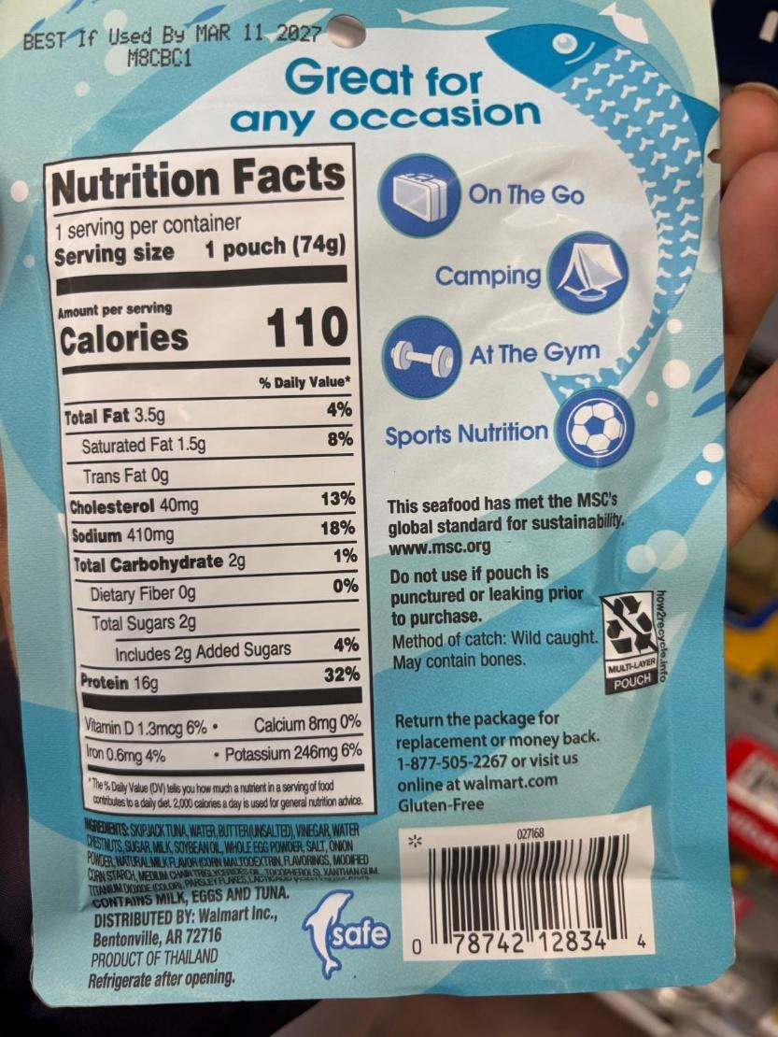
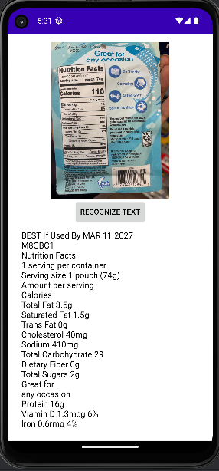
USING ML KIT
Text recognition
- Using Process() – output VisionText it shows nitrition facts but order of text is not linear / irregular.
% values are not read in same line. ocrResultsMl.txt
- Recognised vertical text
- Use Text block line – to observe input:
yet we get same order of text recognized in above(in blocks or line)
  - printing X, Y coordinates these text blocks – could not draw meaningful observation.
- Why "4%" is far away from "Total fat 3.5g"
  - OCR engines (including ML Kit, Tesseract, Vision API) group text into blocks based on whitespace and spacing.
  - In a Nutrition Facts table, the nutrient name and value (e.g., "Total fat 3.5g") are left-aligned, while the %DV column (e.g., "4%") is far to the right.
  - Since there’s a big gap, OCR assumes "4%" is a separate block, even though visually it’s the same row.

- Can we use Ml kit to do margin based detection?
only with ML kit we cant do, we need uses OPENCV canny edge detection.

ML kit : line by line
abstraction tool on Plain text -> summary tool for expiry date.
Nutrition Facts boundary
- Keyword-based boundary (using ML Kit only)
  - Look for the block/line that contains "Nutrition Facts".
  - Take its bounding box as a starting point.
  - Expand downward until you hit another keyword ("Ingredients", "Distributed by", etc.) or the end of image.
  - The combined rectangle = your “Nutrition Facts table boundary”.
  - Then you can crop that region and re-run ML Kit on the cropped bitmap for cleaner results.
  - Apply line alignment heuristics (like grouping by Y-coordinate) to re-combine 4% with Total Fat 3.5g - pending
Implemented this successfully
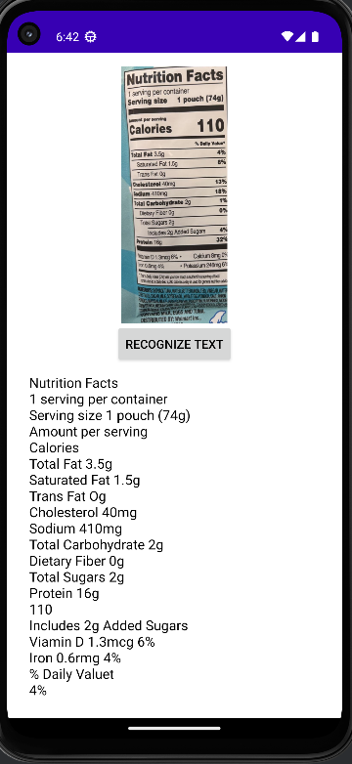
First fix: fix daily value inline with nutrition name & present data in Table rows.
second fix: Present every row as it is without losing data
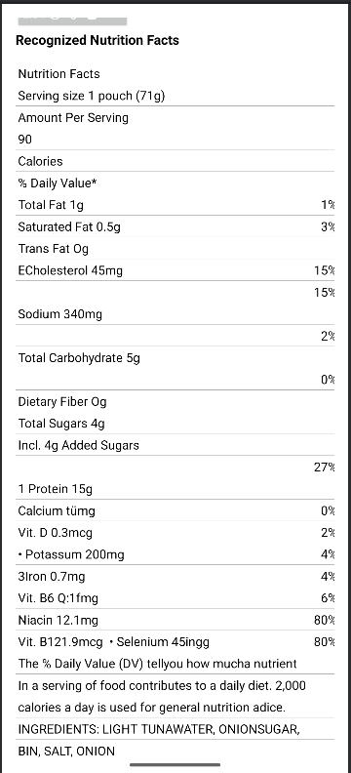
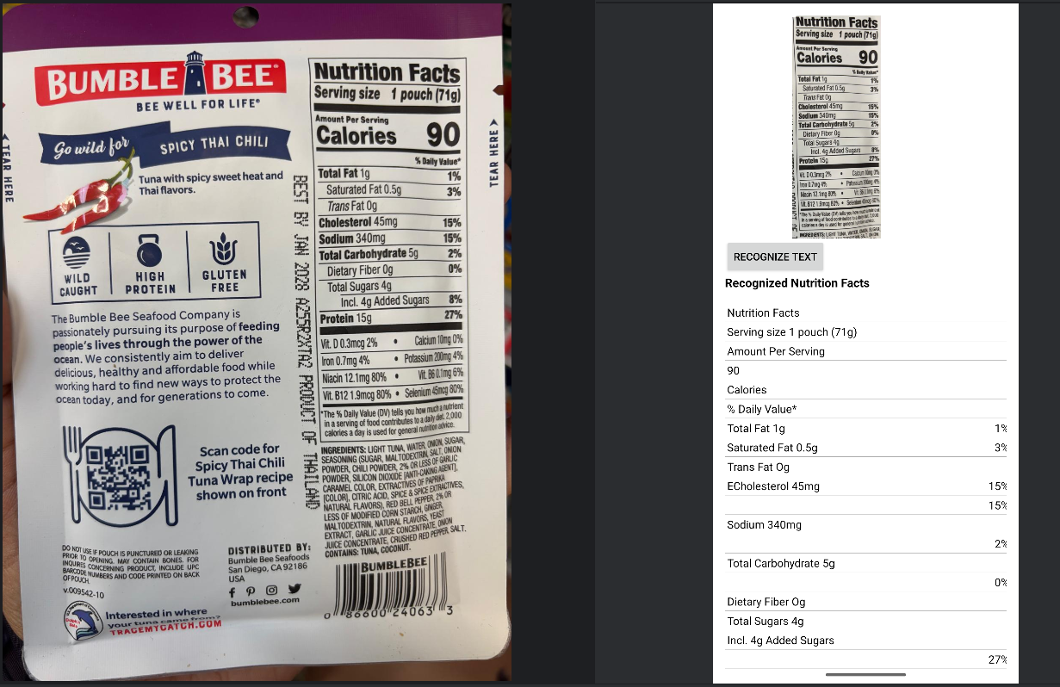

LIMITATIONS:
- It can perform ocr with image less than 1MB only with kotlin framework
- This approach fails if INGREDIENTS Keyword is not visibly seen / not recognised / if INGREDIENTS is not below the Nutrition facts panel
- Prolonged startup time for the app
- Occasional UI delays or stutters during processing
- Higher battery usage on lower-end or mid-range devices
These performance constraints should be considered when deciding whether ML Kit is suitable for applications that require real-time responsiveness or must operate efficiently on devices with limited hardware capabilities.
Due to these limitations not feasible enough , switching to OCR with AWS textract

